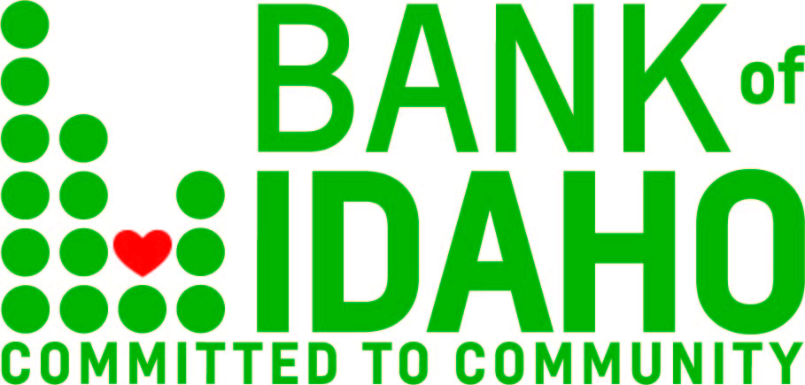
July 27, 2021
Contact: Tyler Kraupp
Phone: 1.208.390.0667
tylerkraupp@bankofidaho.net

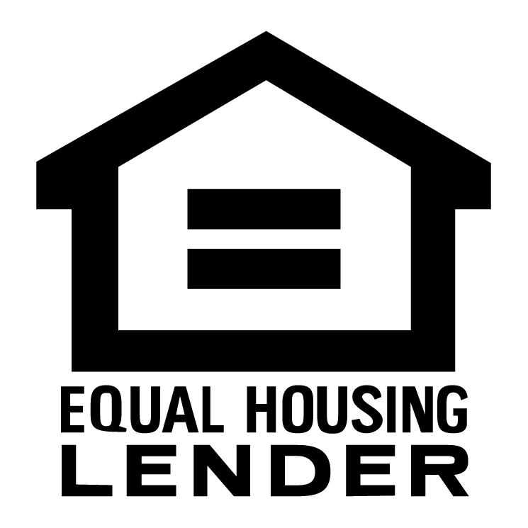
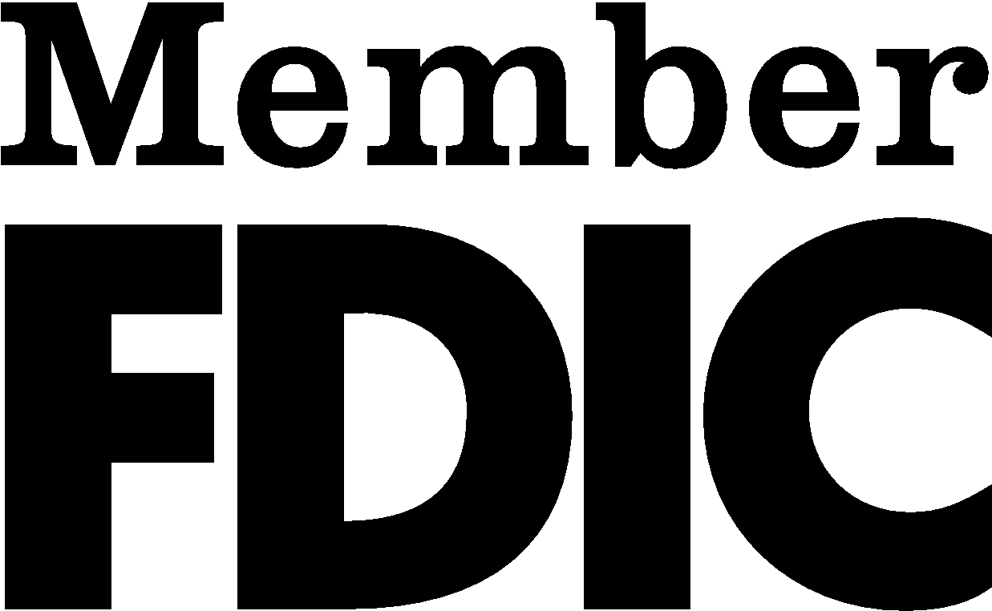

FOR IMMEDIATE RELEASE:

Bank of Idaho leads state in SBA lending.

BOISE – Approaching one year into an expansion of their SBA lending capacity, Bank of Idaho leads the state as the Boise District Office's top dollar-lender of Small Business Administration loans.
"About a year ago we identified the need, and decided to spin off a department especially for SBA loans," said Bank of Idaho Vice President and SBA Department Manager Tony Vahsholtz. "Topping some formidable competition validates that decision."
With nine months of the fiscal year reported, Bank of Idaho has topped its in-state peers in dollars lent, with nearly $22 million on the books. SBA lending can be a crucial resource for small business owners, which are Bank of Idaho's key clientele.
"We saw the writing on the wall early-on," said bank President and CEO Jeff Newgard. "We decided the more muscle we put behind SBA loans, the more small businesses we can help. We jumped in with both feet and haven't looked back since."
While other lenders eventually shied away from PPP lending, Bank of Idaho has never balked. Their SBA Department is an extension of that mindset.
"SBA programs can be transformative if they get to people who need them," Vahsholtz said. "We work hand-in-hand with small business owners to make sure that happens."
To learn more a bout Bank of Idaho's SBA offerings, go to bankofidaho.com/sba-loans.

----- END -----

