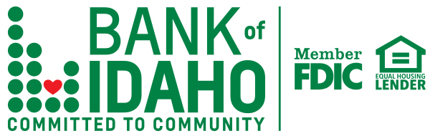

For Immediate Release

BOISE - Bank of Idaho continues its expansion in the western part of the state by opening its second Boise location at 6981 W. Overland Road. The branch opened for business on October 1, 2019.

Bank of Idaho has been a cornerstone in eastern Idaho since 1985, when their headquarters opened in Idaho Falls. This newest Boise office will be the bank's ninth full-service branch.

Bank of Idaho is a community bank focused on the advancement of small businesses, as they recognize them to be the lifeblood of our state’s economy. The bank focuses on providing tools and support that help build personal long-term relationships with their clients.

“We work hard to learn about our customers," Bank President and CEO Jeff Newgard said. "We strive to gain a deep understanding of their goals and aspirations, so we can anticipate their needs and give them the right tools to succeed. Pair that philosophy with decisions that are made right here at the local level, and it truly sets us apart from many of our competitors."

The Bank of Idaho Overland Branch team will be made up of some familiar faces from the area: Charlie Kouba, V.P. Commercial Banking Manager, Surbir Chadha, V.P. Commercial Loan Officer, Caroline Kennedy, Retail Branch Manager, Katelyn Shaw, Loan Assistant, and Lacy Beck, Universal Banking Associate.

Contact Bank of Idaho’s V.P. of Market Development, Jarod Phillips, at 208-524-5500 or via email at j.phillips@bankofidaho.net.

