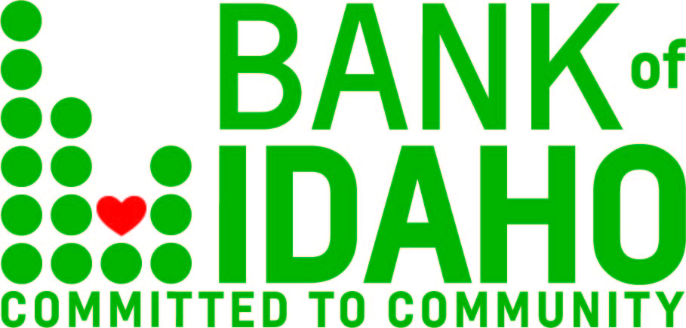
October 9, 2019
Contact: Jarod Phillips
Phone: 1.208.528.9605
j.phillips@bankofidaho.net

FOR IMMEDIATE RELEASE

Bank of Idaho enters OTCQX public exchange

IDAHO FALLS – Bank of Idaho Holding Co. stock now trading over-the-counter.

OTC Markets Group Inc. announced October 2 that Bank of Idaho Holding Co. has qualified to trade on the OTCQX Best Market. Bank of Idaho Holding Co. was previously privately-held.

“We are pleased to welcome Bank of Idaho Holding Co., the first Idaho-based institution to join the OTCQX Best Market,” said Jason Paltrowitz, EVP of Corporate Services at OTC Markets Group. “Bank of Idaho Holding Co. is the fifteenth community bank to join the OTCQX market this year, to provide investors with greater transparency and more efficient trading. We look forward to supporting Bank of Idaho Holding Co. in the public market.”
Bank President and CEO, Jeff Newgard shared: “We are truly excited to be the first Idaho-based bank to join the OTCQX Best Market Group. As a bank, we are focused on supporting small business, the lifeblood of our economy in Idaho. By providing innovative tools and expert guidance, we seek to become the best community bank in the state. We're excited for the opportunities that lie ahead, and we have our sights set on a bright future for Bank of Idaho and the shareholders of Bank of Idaho Holding Co.”
Bank of Idaho Holding Co. was organized in 1997 as the parent company for Bank of Idaho, which received its state banking charter in September 1985. With total assets of $375 Million and growing, the Idaho Falls-based bank presently has 9 full-service branches in operation across southern Idaho, with one additional location pending. In additional to retail and commercial banking, Bank of Idaho also offers a full spectrum of trust and investment services, along with mortgage lending.
Bank of Idaho Holding Co. is the sole owner of Bank of Idaho, a state-chartered commercial bank, and trades under the symbol BOID. U.S. investors can find financial disclosures and quotes for the company at www.otcmarkets.com. OTC Markets Group Inc. (OTCQX: OTCM) operates financial markets for 10,000 U.S. and global securities.
-------- 30 --------

