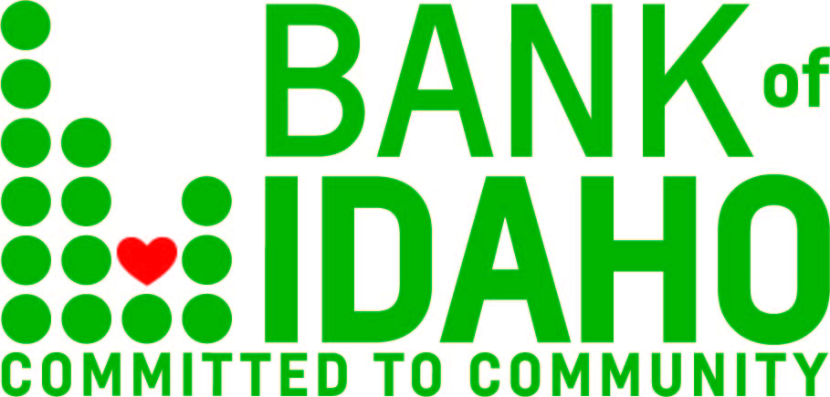

Bank of Idaho Holding Co.
Completes Subordinated Note Offering
Idaho Falls, Idaho, August 25, 2020 – Bank of Idaho Holding Co. (OTCQX: BOID) (the “Company”), the holding company for Bank of Idaho, announced that it has completed a private placement of $10.0 million in aggregate principal amount of fixed-to-floating rate subordinated notes to certain qualified institutional accredited investors. The Company intends to use the net proceeds of the notes offering for general banking purposes with an emphasis on market share, growing its banking operation in both current and new markets.
The notes will initially bear a fixed interest rate of 5.75% per annum until September 15, 2025, after which time until maturity in August 31, 2030, or an earlier redemption date, the interest rate will reset quarterly to an annual floating rate equal to 90-day average SOFR plus 525 basis points. The Company may redeem the notes, in whole or in part, after September 25, 2025. Any redemption will be at a redemption price equal to 100% of the principal amount of the notes being redeemed, plus accrued and unpaid interest. The notes are not subject to redemption at the option of the holders.
Jeff Newgard, the President and CEO of Bank of Idaho Holding Co., commented on the successful offering. “As a bank, we are focused on supporting small business, the lifeblood of our economy in Idaho. We believe that relationships matter and ultimately people bank with people. That mantra and mission has led us to our growth thus far. We are excited for the opportunities that lie ahead, and we have our sights set on a bright future for Bank of Idaho and the shareholders of Bank of Idaho Holding Co.” Newgard noted.
Stinson LLP served as counsel to Bank of Idaho Holding Co., and MJC Partners, LLC, served as the sole placement agent for the offering.
About Bank of Idaho Holding Co.
Bank of Idaho Holding Co. was organized in 1997 as the parent company for Bank of Idaho, which received its state banking charter in September 1985. Bank of Idaho Holding Co. is the sole owner of Bank of Idaho, a state-chartered commercial bank, and trades under the symbol BOID.
About Bank of Idaho
With total assets of $551mm and growing, the Idaho Falls-based bank presently has 10 full-service branches in operation across southern Idaho. In addition to retail and commercial banking, Bank of Idaho also offers a full spectrum of trust and investment services, along with mortgage lending. For more information, please visit https://www.bankofidaho.com/or call (208) 524-5500.
About MJC Partners, LLC
MJC Partners, LLC is a leading Los Angeles-based boutique investment banking and advisory firm providing a full range of strategic, transactional and valuation-related services to clients across multiple industry groups with a focus on financial services. For more information about MJC Partners, visit www.mjcpartners.com.
Forward Looking Statements
This news release may include forward-looking statements within the meaning of Section 27A of the Securities Act of 1933, as amended, and Section 21E of the Exchange Act of 1934, as amended, and Bank of Idaho Holding Co. and Bank of Idaho (together, the “Company”) intend for such forward-looking statements to be covered by the safe harbor provisions for forward-looking statements contained in the Private Securities Litigation Reform Act of 1995. Future events are difficult to predict, and the expectations described above are necessarily subject to risk and uncertainty that may cause actual results to differ materially and adversely.
Forward-looking statements can be identified by the fact that they do not relate strictly to historical or current facts. They often include the words "believe," "expect," "anticipate," "intend," "plan," "estimate," or words of similar meaning, or future or conditional verbs such as "will," "would," "should," "could," or "may." These forward-looking statements are not guarantees of future performance, nor should they be relied upon as representing management's views as of any subsequent date. Forward-looking statements involve significant risks and uncertainties and actual results may differ materially from those presented, either expressed or implied, in this news release. Factors that might cause such differences include, but are not limited to: the Company’s ability to successfully execute its business plans and achieve its objectives; changes in general economic and financial market conditions, either nationally or locally, in areas in which the Company conducts its operations; changes in interest rates; continuing consolidation in the financial services industry; new litigation or changes in existing litigation; increased competitive challenges and expanding product and pricing pressures among financial institutions; legislation or regulatory changes which adversely affect the Company’s operations or business; loss of key personnel; and changes in accounting policies or procedures as may be required by the Financial Accounting Standards Board or other regulatory agencies.
The Company undertakes no obligation to publicly revise these forward-looking statements to reflect subsequent events or circumstances.
This announcement is for informational purposes only and does not constitute an offer to sell or the solicitation of an offer to buy securities.
Media Contact:
Tyler Kraupp
Director of Marketing, Bank of Idaho
tylerkraupp@bankofidaho.net | 208-390-0667

